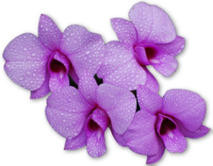 | 51st Tropical QLD Orchid Council Conference | 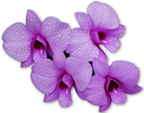
 | 2nd – 3rd July 2022
 | Mackay Entertainment & Conference Centre
 | Alfred Street, Mackay. Queensland

Registration Details (Please Print Clearly) – all correspondence will be addressed to the Primary Registrant.
Primary Registrant
Title (Mr/Mrs/Ms/Dr/Prof.) ………… First Name ………………………… Family Name ……………………………….
Postal Address …………………………………………………………………………. Suburb/Town …..……………………………
State …………………. Post Code ……………………… Country ……………….………………………………………………………
Email Address ………………………………………………………………………….…………………………………………………………
Phone (please include country code area) ……………………………… Mobile ……………………………………………
Name Badge Details: (preferred Name for Badge) …….…………………….………………………………………………..
Society/Orchid Club/other for Badge ……………………………………………………………………………………………..
Tabling Orchids ⃝ Foliage ⃝
Judge ⃝ Please Indicate Authority: …………………………… Preferred Genera: ……………………….…
Special Requirements (Please specify dietary requirements) …………………………………………………………
**********************************************************************************
Accompanying Registrant (Partner)
Title (Mr/Mrs/Ms/Dr/Prof.) ………… First Name ………………………… Family Name ………………………………..
Name Badge Details: (preferred Name for Badge) …………………………………………………………………………….
Society/Orchid Club/other for Badge ……………………………………………………………………………………………..
Tabling Orchids ⃝ Foliage ⃝
Judge ⃝ Please Indicate Authority: ………………………….. Preferred Genera: …………………………..
Special Requirements (Please specify dietary requirements) ………………………………………………………….
Early Bird Registrations close
Full Registrations close
Late registrations Accepted with restrictions.
All enquiries to MDOS Secretary.
Email: mdos.secretary@gmail.com
Telephone (within Australia): 0435 002 990 International: +61 435 002 990
Registration Cancellations: Cancellations made before 20th June 2022 will be refunded, less 30% to cover administration costs. No registration will be made after this date. Cancellations will not be accepted unless submitted to the Secretary in writing before above mentioned date.
Disclaimer: The conference hosts, organising committee and their agents act only as organisers of these activities and do not accept responsibility for any act or omission on the part of the service providers. No liability is accepted for incorrect description, delay, death damage or personal injury.
Activities: The conference organisers reserve the right to cancel or vary activities, if minimum numbers are not reached or if maximum numbers are exceeded. Full registrants have priority to all events and casual vacancies will be allocated in order of enquiry.
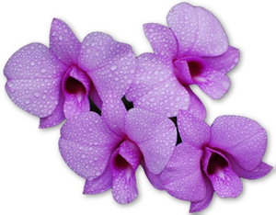 | 51st Tropical QLD Orchid Council Conference | 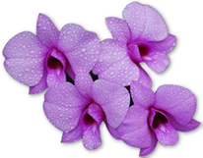
 | 2nd – 3rd July 2022
 | Mackay Entertainment & Conference Centre
 | Alfred Street, Mackay. Queensland
Primary Registrant’s Name ……………………………………………………………………………………………...
Accompanying Registrant’s/ Partner Name ………………………………………………………………………….
All Prices Quoted below are per registrant, in Australian Dollars and include GST.
Please complete sections applicable to all registrants.
Full Registration  2nd – 3rd July 2022  2 days including set up. Registration includes: - Daily Admission to conference Venue, all lectures, Mayoral Reception and Orchid Show Preview, early entry for photography, pre-purchasing opportunities and Registration Satchel that will be shared between Primary and Accompanying Registrants (Partner) | Early Bird Registration  Paid by 31st March 2022  Primary Registrant  Accompanying Registrant/Partner | No of Delegates  ……… x $120 AUD  …..…. x $120 AUD | Payments  $........................
 | Normal Registration  Paid after 20th June 2022  Primary Registrant  Accompanying Primary Registrant  Closes 24th June 2022  Late registration*  Primary Registrant  Accompanying Primary Registrant | …..…. x $150 AUD  ……… x $150 AUD  ……… x $180 AUD  …...... x $180 AUD | $.......................  $.......................
MAYORAL RECEPTION  1st July 2022 | Complimentary to Full registration (Primary/ Accompanying Registrant)  For catering purposes, please indicate if you will be attending | Attending  ⃝ Yes ⃝ No  Number…………….
GALA AWARDS DINNER  2nd July 2022 | Primary and Accompanying Registrant | Per person  ………. X $75 AUD | $..............................
Total payment for registration< awards dinner and gala awards dinner |  |  | $
REGISTRATION AND PAYMENT DEADLINE EARLY BIRD 31st March 2022 / NORMAL 20th June 2022
Please post your Registration and Payments to TQOC and MDOS Conference , P.O. Box 776, Mackay, Queensland. 4740. Australia.
Payment Details (Please make cheque/money order payable to MDOS Inc Account)
Cheque ⃝ Money Order ⃝ Payment of $ AUD………………………. is enclosed.
Direct deposit: Bank: Bank Of Queensland BSB: Account No:
(Please use Primary Registrant’s name as payment reference and post/email registration form)
Late Registrations will be accepted with restrictions up to 24th June 2022. The organising Committee cannot guarantee that late registrants will receive all inclusions for full registrants.

